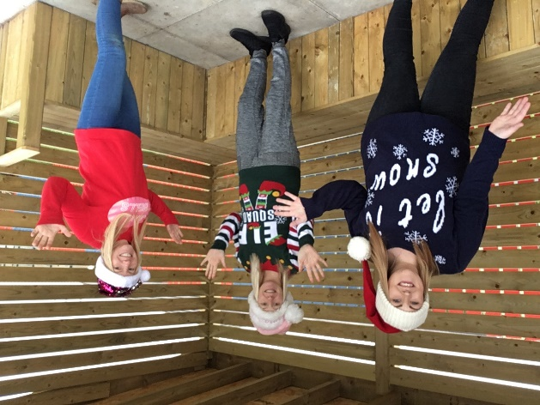

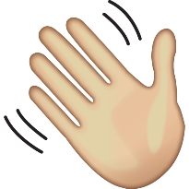
Hi everyone, we want to tell you just how amazing you’ve been, these are very hard times due to Covid-19, WELL DONE!
All of us at SNOOP are working especially hard to plan and prepare for you coming back to SNOOP as we miss you all so much.
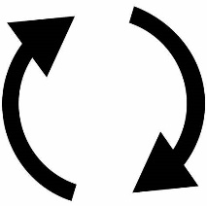
There has been lots of changes this year and we are so proud of how you have managed and adapted to these.
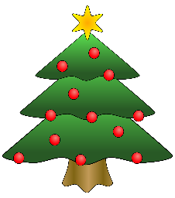
As the festive season approaches, we wish you a very Merry Christmas and hope that 2021 will be a much better year for everyone.
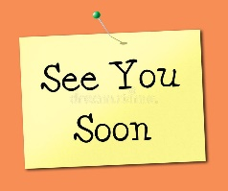
This time will pass, we will see you again soon, keep smiling, keep being you, you are doing so well!

Stay safe, big hugs –
SNOOP – Sophie, Jenni and Jenny

